Negotiated Learning - A Short Course For Students, By Students!
Background
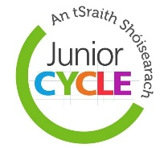 | Although the new Junior Cycle focuses on student voice, it can be difficult for young people to make decisions about their learning and to learn about the things that matter to them. This is because the subjects at school already have a detailed plan for what you should learn. There often isn’t time to focus on the bits that really matter to you.
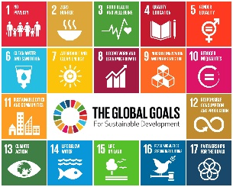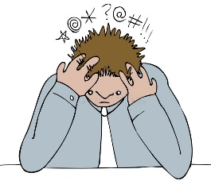 | It can be difficult for young people to make sense of our rapidly changing world, especially when you look at what’s going on in the world right now. Biodiversity loss and the climate crisis, global health pandemics and mental health, conflicts, political divides, fake news and social isolation, inflation and the cost-of-living crisis, and the rise of social media and AI to name a few.  When the subjects at school already have a plan for what you should learn, where can you find the time, support and resources to understand and do anything about these issues? How do you know that what you’re seeing online is true or that you can trust it? Why do so many people have so many different views on different issues? What actions can you take to tackle some of these issues? Where do you even begin?!
So, what is the Negotiated Learning Short Course?
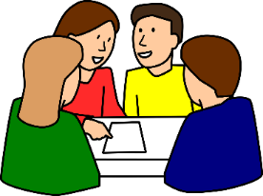 | Negotiated Learning is an exciting short course that’s designed for students, by students. It will give you the power to shape your own learning and allow you to have a real voice in your education in a fair, democratic way. It’s called ‘Negotiated Learning’ because you will negotiate (agree on) exactly what you want to learn about with your teacher, based on your concerns about yourself and the world around you.
Why Should You Do This Short Course?
In this short course you’ll address the issues that really matter to you. You will learn:
- How to answer the questions you have about the world that can’t be answered in a regular class,
- How to solve real world problems and think critically in our rapidly changing world,
- How to work together with your class and teachers to learn about what matters to you,
- How to use your voice and make real decisions,
- To build the skills you need to live as a democratic, global citizen.
Most importantly, you will have the time to figure things out at your own pace. This supports the Principles and Key Skills for Junior Cycle, and the skills you learn here will also prepare you for Senior Cycle.
What Will This Short Course Look Like?
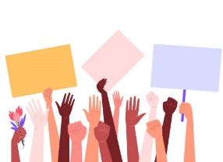  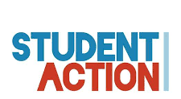 | Together, your class will decide on a topic of learning that is important to you. For example, this could be something that you find worrying in the world, like climate change, conflicts or pollution, or it could be something you want to get active with, like health and wellbeing or sustainability. These are just examples, and the work you do will be based on your ideas and what is relevant to your lives. Your teacher will support you in this and will be learning alongside you. You will get to negotiate what the learning looks like, what questions you want answered and how you will answer them. Whether it’s visual arts, presentations, performances, community action, workshops, podcasts, debates, protests, reflective diaries, portfolios, or anything else under the sun, you get to decide what this short course will look like for you!

